

SIMATS ENGINEERING
Saveetha Institute of Medical and Technical Sciences
(Declared as Deemed to be University under Section 3 of UGC Act 1956)

A CAPSTONE PROJECT REPORT
PROJECT TITLE:
ACROSS A MULTI-STATION WIRELESS LAN (p) ,CAN WI-FI 6
(802.11 ax) with OFDMA SCHEDULING(i) RATHER THAN
LEGANCY 802.11Nn (C) ,LIFT AGGREGRATE THROUGHPUT
WHEN STATION DENSITY IS HIGH (o)
A Capstone Project Report submitted in partial fulfilment of the requirements
for the Course of
COMPUTER NETWORKS (CSA0710)
to the award of the degree of
BACHELOR OF TECHNOLOGY
IN

COMPUTER SCIENCE ENGINEERING
Submitted by
RAHULNARAYANAMOORTHI
1921260036
Under the Supervision of

Dr. KUMARAN .G
Saveetha Institute of Medical and Technical Sciences
Chennai-602105
SEPTEMBER 2026

BONAFIDE CERTIFICATE
This is to certify that the Capstone Project entitled “ACROSS A MULTI STATION
WIRELESS LAN (p), CAN WI-FI 6 (802.11ax) WITH OFDMA SCHEDULIG
(i)RATHER THAN LEGACY 802.11 N © ,LIFT AGGREGATE THROUPUT
WHEN STATION DENSITY IN HIGH (O)” has been carried out by RAHULNARAYANAMOORTHI 1921260036 under the supervision of Dr. KUMARAN G and is submitted in partial fulfilment of the requirements for the current semester of the B.Tech IT Engineering at Saveetha Institute of Medical and Technical Sciences, Chennai.
COURSE COORDINATOR | COURSE FACULTY
Dr. S. SIVAGAMI , Course Coordinator  Professor ,  Department of DATA VISTA / CSE  SIMATS Engineering, SIMATS, Chennai – 602105. | Dr. KUMARAN G, Professor  Department of SUPER COMPUTING / CSE  SIMATS Engineering, SIMATS, Chennai – 602105.

SIMATS ENGINEERING
Saveetha Institute of Medical and Technical Sciences Chennai-602105

DECLARATION
We, GOWTHAM S COMPUTER SCIENCE Engineering, SIMATS Engineering, Saveetha
Institute of Medical and Technical Sciences,
Chennai, hereby declare that the Capstone Project Work entitled “ACROSS A MULTI STATION WIRELESS LAN (p), CAN WI-FI 6 (802.11ax) WITH OFDMA SCHEDULIG
(i)RATHER THAN LEGACY 802.11 N © ,LIFT AGGREGATE THROUPUT WHEN
STATION DENSITY IN HIGH” is the result of our own bonafide efforts. To the best of our knowledge, the work presented herein is original, accurate, and has been carried out in accordance with the principles of engineering ethics and academic integrity. All sources, references, data, and other materials used in the project have been appropriately acknowledged. We further declare that the data, results, analysis, and findings presented in this report have not been fabricated, falsified, or manipulated. Any external tools, software, datasets, computational resources, or AI-assisted tools used during the project have been appropriately disclosed. We confirm that all applicable ethical, academic, institutional, and professional requirements have been duly followed throughout the planning, execution, analysis, and documentation of the project.
Place: Chennai
Date: September 3, 2026
Signature of the Students with Names:
1. RAHULNARAYANAMOORTHI __________________

SIMATS ENGINEERING
Saveetha Institute of Medical and Technical Sciences Chennai-602105

SIMATS ENGINEERING | September 2026

INDIVIDUAL CONTRIBUTION STATEMENT
The project presentation identifies four team members but does not specify individual task percentages. The following distribution is therefore a provisional equal-share representation and should be confirmed by the team/faculty before final submission.
Student / Register No. | Specific Responsibilities | Design & Development | Testing & Analysis | Report Contribution | Approx. Contribution
Rahul .N /  1921260036 | Wireless simulation and topology work | Simulation setup | Throughput/latency review | Ch. 1–2 | 25% (provisional)
Gautham / 1925260007 | Protocol comparison and module analysis | CSMA/CA–  OFDMA analysis | Latency/energy analysis | Ch. 3 | 25% (provisional)
Gowtham .S / 1971260007 | Performance evaluation and documentation | Parameter/result organization | Throughput and station-scale analysis | Ch. 4 | 25% (provisional)
Krishna. M / 1924260154 | Topology/supporting documentation | Network topology representation | Result consolidation | Ch. 5 + Appendices | 25% (provisional)
Total |  |  |  |  | 100%

ABSTRACT
Wireless networking performance depends strongly on channel bandwidth, medium-access strategy, station density and the efficiency of packet transmission. This capstone project evaluates IEEE 802.11ax (Wi-Fi 6) wireless networking through a set of simulation-oriented modules using NS-3 / NetSim concepts and Cisco Packet Tracer topology configurations. The work investigates four related engineering questions: the effect of 20 MHz, 40 MHz and 80 MHz channel widths on aggregate throughput; the latency advantage of OFDMA scheduling over traditional CSMA/CA contention; the energy-per-packet behavior of 802.11ax compared with 802.11n; and the degradation in per-station throughput as WLAN station count increases.
For the channel-width study, an 802.11ax network with one access point and 16 active stations was evaluated under saturated UDP CBR traffic. The reported aggregate throughput values were 143 Mbps for 20 MHz, 287 Mbps for 40 MHz and 575 Mbps for 80 MHz. A second module compared access latency for 10 active stations using CSMA/CA and OFDMA. The reported average latency decreased from 24.5 ms to 4.2 ms, with OFDMA peak jitter reported as 5 ms. A third module examined energy-per-packet consumption for 802.11n and 802.11ax under identical CBR traffic, with reported values showing lower energy consumption for 802.11ax in both 10node and 50-node cases. Finally, station-scale analysis compared 5 and 20 stations on a single AP and reported more than 82% reduction in per-station throughput at the higher station count.
Overall, the project demonstrates the system-level trade-offs associated with Wi-Fi 6: wider channels can substantially increase aggregate throughput, OFDMA can reduce access latency by reducing contention, and Wi-Fi 6 mechanisms can improve energy efficiency under the stated simulated conditions. The results also show that increasing station density can impose significant throughput penalties, highlighting the importance of medium-access scheduling and network capacity planning.
Keywords: IEEE 802.11ax, Wi-Fi 6, OFDMA, CSMA/CA, Aggregate Throughput, Wireless Network Simulation

TABLE OF CONTENTS
Sl. No. | Title | Page No.
i | Certificate from the Supervisor | ii
ii | Declaration by the Candidate | iii
iii | Individual Contribution Statement | iv
iv | Abstract | v
v | List of Figures | vi
vi | List of Tables | vii
vii | List of Abbreviations | viii
1 | Chapter 1: Introduction and Engineering  Problem | 1
2 | Chapter 2: Literature Review and Existing  Solutions | 5
3 | Chapter 3: Engineering Design & Tradeoffs, Sustainability, Ethics, Safety, Risk & Security | 8
4 | Chapter 4: Implementation, Testing & Results, Project Management | 13
5 | Chapter 5: Conclusion, Future Work and  Reflection | 18
 | References | 20
 | Appendices | 21

LIST OF FIGURES
Figure No. | Figure Name | Page No.
Fig. 1 | Project overview and team | 1
Fig. 2 | Channel bandwidth simulation overview | 2
Fig. 3 | Cisco Packet Tracer topology for bandwidth study | 4
Fig. 4 | CSMA/CA vs OFDMA access model | 10
Fig. 5 | OFDMA latency simulation setup | 12
Fig. 6 | 802.11n vs 802.11ax energy analysis | 13
Fig. 7 | Energy-analysis topology | 15
Fig. 8 | WLAN station-scale topology | 17

LIST OF TABLES
Table No. | Table Name | Page No.
Table 1 | Simulation inputs and parameters | 3
Table 2 | Aggregate throughput outputs | 4
Table 3 | OFDMA vs CSMA/CA latency outputs | 11
Table 4 | Energy simulation parameters | 14
Table 5 | Energy-per-packet outputs | 16
Table 6 | Requirements and acceptance criteria | 13
Table 7 | Risk register | 12
Table 8 | Project milestones and responsibilities | 17

LIST OF ABBREVIATIONS / SYMBOLS
Symbol / Abbreviation | Description | Unit
AP | Access Point | —
STA | Wireless Station | —
WLAN | Wireless Local Area Network | —
Wi-Fi 6 | IEEE 802.11ax | —
Wi-Fi 4 | IEEE 802.11n | —
OFDMA | Orthogonal Frequency Division Multiple  Access | —
CSMA/CA | Carrier Sense Multiple Access with Collision Avoidance | —
CBR | Constant Bit Rate | —
RU | Resource Unit | —
UDP | User Datagram Protocol | —
TWT | Target Wake Time | —
Mbps | Megabits per second | Mbps
ms | Milliseconds | ms
mJ | Millijoule | mJ

CHAPTER 1 INTRODUCTION AND ENGINEERING PROBLEM
1.1 Background
Wireless LANs must share a common radio medium among multiple stations. As the number of stations grows, contention, backoff and retransmission overhead can reduce effective performance. The project focuses on WiFi 6 (IEEE 802.11ax) and examines how channel width, OFDMA scheduling and network density affect measurable performance indicators such as aggregate throughput, access latency and energy consumed per packet.
The project presentation frames the work around computer-network simulation and data-link control mechanisms. It uses 802.11ax configurations, multi-station WLAN topologies, CBR traffic and comparative protocol analysis. Cisco Packet Tracer topology representations are used alongside NS-3 / NetSim simulation environments.
1.2 Need for the Project
- To quantify how increasing channel width from 20 MHz to 80 MHz changes aggregate throughput.
- To examine whether OFDMA scheduling reduces channel-access latency compared with CSMA/CA contention.
- To evaluate energy-per-packet behavior of 802.11ax relative to 802.11n under the stated traffic conditions. • To understand the performance penalty associated with increasing the number of active stations in one WLAN cell.
- To connect data-link control mechanisms with observable engineering metrics.
  - Problem Statement
The engineering problem is to evaluate the interacting effects of channel bandwidth, medium-access strategy, energy behavior and station density in multi-user wireless networks while keeping the stated traffic and topology conditions controlled. The project therefore compares alternative wireless access mechanisms and configurations using measurable outputs rather than relying only on qualitative protocol descriptions.
  - Project Aim
To analyze and compare the performance of wireless network configurations using Wi-Fi 6/802.11ax simulation models, with emphasis on throughput, latency, energy-per-packet consumption and station-density effects.
  - Project Objectives
- Evaluate 20/40/80 MHz channel-width performance.
- Compare OFDMA and CSMA/CA channel-access latency.
- Compare 802.11n and 802.11ax energy-per-packet results.
- Measure the effect of increasing WLAN station count from 5 to 20.
- Interpret results in terms of data-link control and system-level engineering trade-offs.

CHAPTER 1 – CONTINUED
1.6 Scope
- Included: Wi-Fi 6 channel-width analysis, OFDMA vs CSMA/CA latency analysis, 802.11n vs 802.11ax energy analysis, and 5-vs-20-station WLAN throughput analysis.
- Included: AP/STA topology representations, CBR traffic profiles, wireless MAC/PHY configuration concepts, and reported simulation outputs.
- Excluded: real-world RF propagation measurements, commercial benchmarking, and field deployment measurements, because they are not reported in the supplied project material.
- Assumption: the reported values are treated as outputs of the stated simulation configurations and are not independently re-measured in this report.
- Boundary condition: conclusions apply to the configurations and loads described in the project presentation.
1.7 Expected Engineering Outcome
The intended outcome is a structured simulation-based evaluation of Wi-Fi 6 performance characteristics, supported by comparative tables, topology representations and engineering interpretation. The final report consolidates the project modules into one system-level analysis.
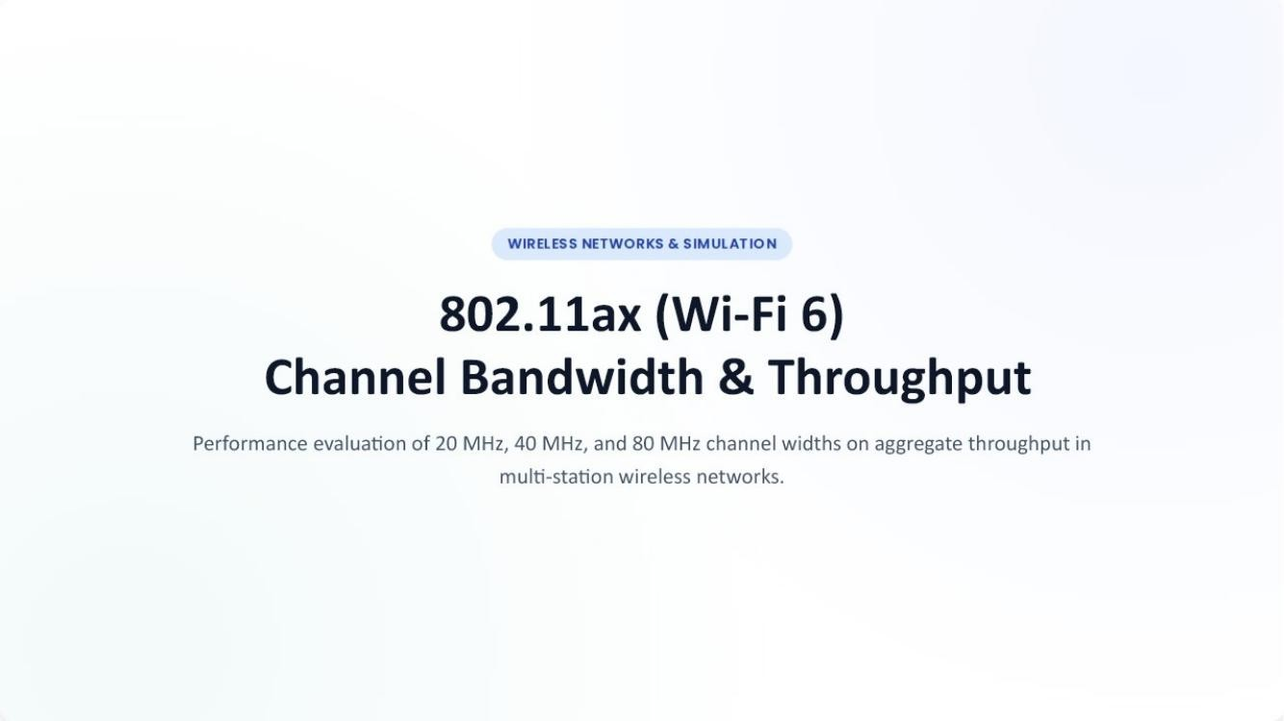

CHAPTER 2 LITERATURE REVIEW AND EXISTING SOLUTIONS
2.1 Review Method
The supplied project material identifies the relevant technologies and simulation approaches directly: IEEE 802.11n, IEEE 802.11ax, CSMA/CA, OFDMA, CBR traffic, NS-3 / NetSim and Cisco Packet Tracer. The literature-review section of this report therefore uses the project presentation as the primary source for identifying the compared approaches. External literature was not supplied with the project files and has not been added as if it were part of the original project evidence.
2.2 Review of Existing Work
The project compares legacy contention-based access with Wi-Fi 6 scheduled multi-user access. CSMA/CA is described as relying on random backoff and contention, while OFDMA is described as subdividing the channel into Resource Units (RUs) so that multiple stations can be scheduled in parallel. The energy module additionally introduces Target Wake Time (TWT) as a mechanism relevant to battery-powered stations.
The project also considers channel bonding through 20, 40 and 80 MHz configurations. The reported throughput progression indicates that wider bandwidth was associated with higher aggregate throughput under the stated 16station saturated-traffic configuration.
2.3 Comparative Analysis
Existing Approach | Advantages | Limitations | Relevance
CSMA/CA | Simple contention-based access; established legacy  mechanism | Random backoff and contention increase overhead as node density rises | Baseline for latency, energy and density comparisons
OFDMA / Wi-Fi 6 | Parallel resource allocation; lower contention overhead | Requires scheduling and Wi-Fi 6-capable configuration | Primary proposed mechanism
20/40/80 MHz channel widths | Allows comparison of spectrum allocation and throughput | Wider channels depend on available spectrum and configuration | Used for aggregate-throughput study
2.4 Research / Engineering Gap
Within the supplied project material, the key engineering gap is the need to connect individual protocol mechanisms with measurable system-level outcomes. The project addresses this by placing throughput, latency, energy and station-density outputs side by side.
2.5 Proposed Contribution
The contribution is a consolidated simulation study that links Wi-Fi 6 channel width, OFDMA scheduling, energy behavior and station scaling to quantitative outputs reported by the project modules.

CHAPTER 3 ENGINEERING DESIGN & TRADE-OFFS, SUSTAINABILITY, ETHICS, SAFETY, RISK & SECURITY
3.1 Requirements
Stakeholder | Requirement
Student/project team | A reproducible simulation-oriented comparison of wireless configurations.
Course/faculty | Demonstrate data-link protocol understanding and engineering analysis.
Network user | Understand throughput and latency implications of bandwidth, contention and station density.
Battery-powered device perspective | Evaluate relative energy-per-packet behavior under controlled traffic.
Functional & Non-Functional Requirements
Requirement Type | Measurable Target
Functional | Compare 20/40/80 MHz aggregate throughput.
Functional | Compare CSMA/CA and OFDMA average access latency.
Functional | Compare 802.11n and 802.11ax energy per packet.
Functional | Compare 5- and 20-station per-station throughput.
Non-Functional | Keep traffic/topology conditions explicit for each comparison.
Non-Functional | Present results in tables/figures with traceable source configurations.
3.2 Constraints & Applicable Standards
Standard / Code | Requirement | How Applied
IEEE 802.11ax (Wi-Fi 6) | High-efficiency WLAN operation and OFDMA-based access | Used as the principal wireless configuration.
IEEE 802.11n (Wi-Fi 4) | Legacy high-throughput WLAN comparison | Used as the baseline in energy analysis.
Institutional capstone format | Required chapter/report structure | Used as the report organization template.

CHAPTER 3 – DESIGN SPECIFICATIONS AND ALTERNATIVES
3.3 Design Specifications
Parameter | Target / Requirement | Unit | Priority
Wi-Fi standard | 802.11ax for main performance studies | — | High
Channel bandwidth | 20 / 40 / 80 | MHz | High
Stations – bandwidth study | 1 AP + 16 STAs | nodes | High
Stations – latency study | 10 STAs | nodes | High
Channel – latency study | 20 MHz with RUs | MHz | High
Energy study station scale | 10 / 20 / 50 | nodes | Medium
CBR traffic | 100 kbps–2 Mbps per node (energy module) | kbps/Mbps | High
Station-scale study | 5 vs 20 STAs | nodes | High
3.4 Alternative Solutions & Evaluation
Alternative 1: Traditional CSMA/CA access. This approach represents contention-based WLAN access with random backoff and retransmission behavior.
Alternative 2: Wi-Fi 6 OFDMA scheduling. This approach allocates Resource Units to multiple stations, reducing the need for every station to contend for the full channel.
Criterion | Weight | CSMA/CA | OFDMA
Performance | High | Baseline; degrades with contention | Higher reported performance in latency/energy studies
Cost | Medium | Conventional configuration | Requires Wi-Fi 6-capable configuration
Safety | Medium | No specific safety issue reported | No specific safety issue reported
Sustainability | Medium | Higher reported energy in comparison | Lower reported energy in comparison
Reliability | Medium | Collision/retry overhead under load | Scheduled parallel access reduces contention overhead
3.5 Selected Design & Detailed Design
The project uses a comparative design rather than a single deployment. OFDMA is selected as the improved mechanism for the Wi-Fi 6 comparisons because the supplied outputs show lower access latency and lower energy-per-packet consumption than the corresponding contention-based baselines. Channel width is varied independently to observe throughput scaling.
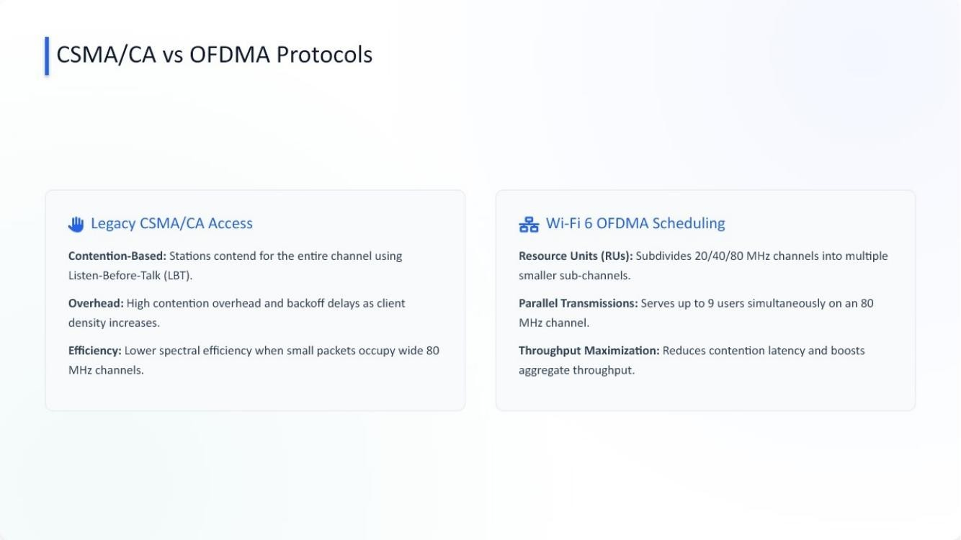

CHAPTER 3 – TRADE-OFFS, SUSTAINABILITY, ETHICS, SAFETY & SECURITY
3.6 Trade-off Analysis
Design Decision | Alternative Considered | Benefit | Disadvantage | Final Decision & Justification
Access method | CSMA/CA | Simple baseline | Contention/backoff overhead | Use as comparison baseline
Access method | OFDMA | Parallel scheduled transmission | Requires Wi-Fi 6 configuration | Use for improvedaccess comparison
Bandwidth | 20 MHz | Lower channel width | Lower reported aggregate throughput | Retain as baseline
Bandwidth | 80 MHz | Highest reported aggregate throughput | Requires wider bonded channel | Use as upper-width comparison
3.7 Sustainability, Ethics, Safety, Risk & Security
Domain | Consideration | Evidence Evaluated | Impact on Final Decision
Sustainability | Energy consumed per packet | Reported 802.11n vs 802.11ax energy outputs | Supports evaluation of Wi-Fi 6 energy efficiency
Ethics | Honest representation of simulated values | Project presentation outputs | No unsupported measured values added
Health & Safety | Wireless laboratory simulation | No physical hazard evidence supplied | No additional physical intervention claimed
Security | Wireless access is a shared medium | Project focuses on performance, not security  testing | Security treated as a design consideration rather than a  tested metric
Risk Register
Risk | Likelihood | Severity | Risk Level | Mitigation | Residual Risk
Incorrect parameter configuration | Medium | High | Medium/High | Record configuration  values before each  run | Medium
Misinterpretation of simulated results | Medium | Medium | Medium | Tie each conclusion to reported outputs | Low/Medium
High station contention | High | Medium | High | Compare scheduled access and station scaling | Medium
Missing real-world RF effects | Medium | Medium | Medium | State simulation boundary clearly | Medium

CHAPTER 4 IMPLEMENTATION, TESTING & RESULTS, PROJECT MANAGEMENT
4.1 Development Approach & Resources
The project follows a modular comparative simulation approach. Each module defines a population, intervention, comparison and outcome (PICO), establishes wireless and traffic parameters, represents the network topology, and then evaluates a reported performance output. The modules use NS-3 / NetSim simulation concepts and Cisco Packet Tracer topology representations.
Resource | Purpose
NS-3 / NetSim | Wireless simulation environment identified in the project.
Cisco Packet Tracer | Topology representation and configuration visualization.
802.11ax / 802.11n modules | Wireless MAC/PHY comparison.
CBR UDP traffic | Controlled traffic load for reported experiments.
AP + STA topology | Multi-station WLAN test structure.
4.2 Hardware / Software / Fabrication Implementation
Tool / Software / Equipment | Purpose | Stage Used
NS-3 / NetSim | Discrete-event wireless simulation | Simulation
Cisco Packet Tracer | WLAN topology and configuration visualization | Topology setup
Cisco AP / WLAN components | Access point representation | Network setup
Wireless laptop/PC nodes | Station representation | Testing

CHAPTER 4 – TEST PLAN & CHANNEL-WIDTH RESULTS
4.3 Test Plan & Verification
Requirement | Test Method | Acceptance Criterion | Specification Required | Achieved | Status
Channel-width comparison | Run/compare 20,  40, 80 MHz configurations | Three outputs available | 20/40/80 MHz | 143/287/575 Mbps | Pass
Latency comparison | Compare 10-station  CSMA/CA and  OFDMA | Average latency values reported | Lower OFDMA  latency | 24.5 vs 4.2 ms | Pass
Energy comparison | Compare 802.11n and 802.11ax | Energy-per-packet values reported | 802.11ax lower | 4.5 vs 8.2 mJ (10 nodes) | Pass
Station scaling | Compare 5 and 20 stations | Per-station degradation  identified | Quantify degradation | >82% reduction reported | Pass
4.4 Results – Aggregate Throughput
Channel Width | Aggregate Throughput
20 MHz | 143 Mbps
40 MHz | 287 Mbps
80 MHz | 575 Mbps
The project reports approximately four-times higher aggregate throughput from 20 MHz to 80 MHz, increasing from about 143 Mbps to 575 Mbps. The reported explanation is channel bonding and increased subcarrier/resource availability in Wi-Fi 6.
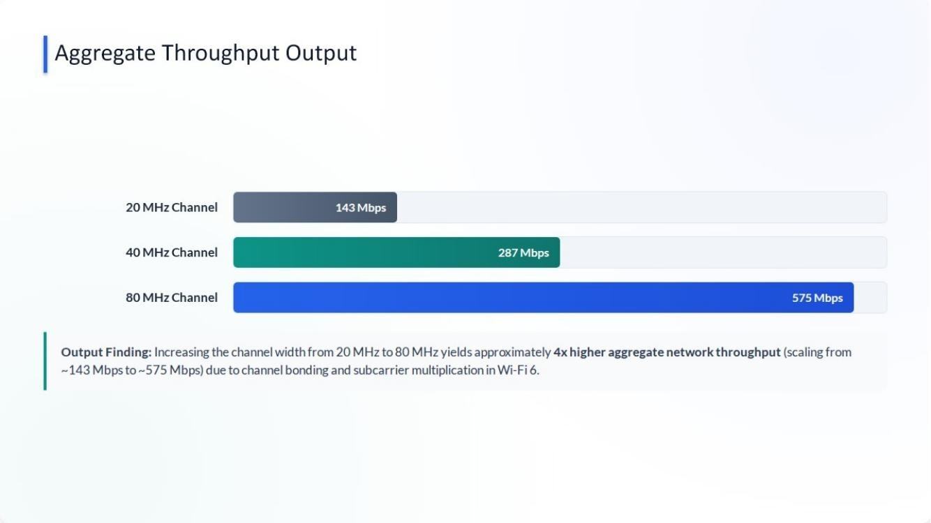

CHAPTER 4 – OFDMA LATENCY ANALYSIS
4.4 Results – Channel Access Latency
Metric | CSMA/CA | OFDMA
Average channel access latency | 24.5 ms | 4.2 ms
Peak jitter | Not specified | 5 ms
Key Result: the supplied project reports that OFDMA multi-user scheduling reduces average channel-access latency by approximately 83% compared with CSMA/CA across 10 active stations. The reported explanation is elimination/reduction of exponential backoff delays through scheduled multi-user transmission.
4.5 Data Analysis & Engineering Judgment
Using the reported averages, the absolute latency reduction is 20.3 ms (24.5 − 4.2 ms), while the percentage reduction is approximately 82.9%, consistent with the project’s reported ~83% figure. This indicates that accesscontrol strategy can be as important as raw channel capacity for latency-sensitive traffic.
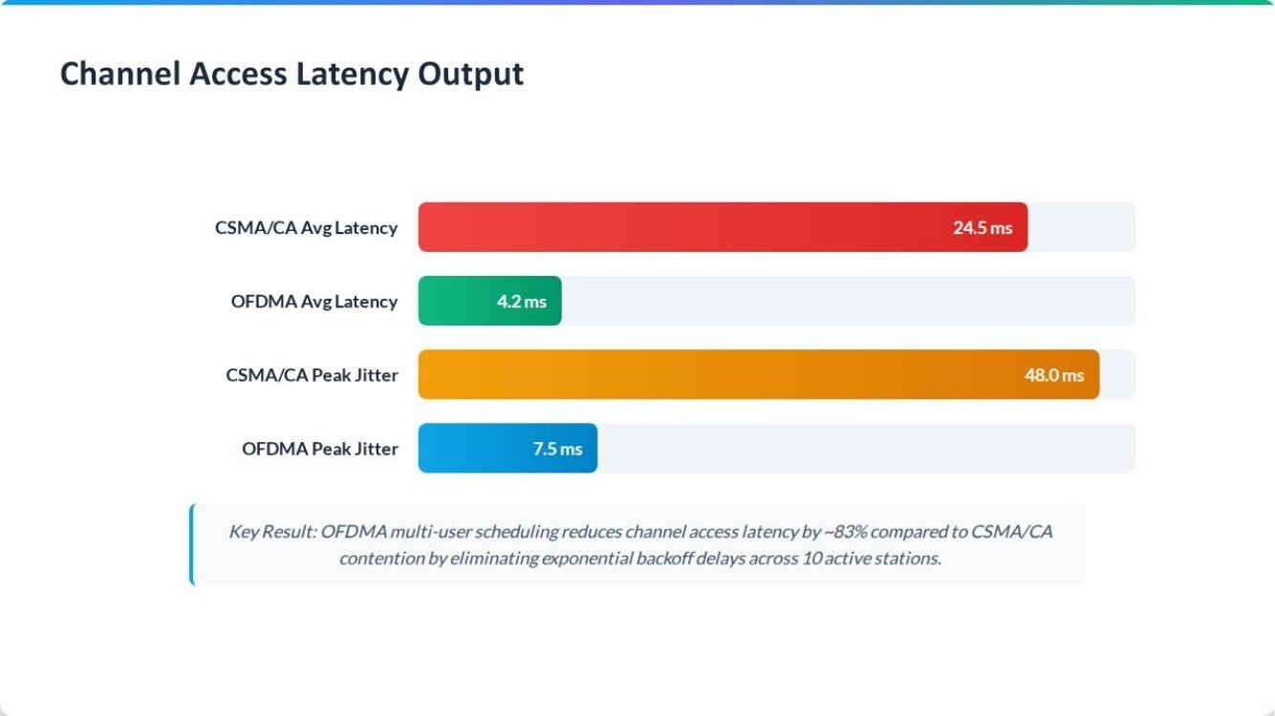

CHAPTER 4 – ENERGY-PER-PACKET ANALYSIS
Energy module configuration
Parameter | 802.11n | 802.11ax | Simulation Input
Traffic | CBR | CBR | 100 kbps–2 Mbps/node
Payload | 512 / 1024 Bytes | 512 / 1024 Bytes | Fixed CBR generator
Channel access | CSMA/CA random backoff | OFDMA multi-user scheduling | MAC comparison
Station nodes | 10, 20, 50 | 10, 20, 50 | Scalable density
Energy model | Tx 280mA, Rx 160mA, Idle 120mA | Tx 260mA, Rx 130mA, Sleep  5mA | Joules/packet
4.4 Results – Energy-per-Packet
Configuration | Energy per Packet
802.11n – 10 nodes | 8.2 mJ/pkt
802.11ax – 10 nodes | 4.5 mJ/pkt
802.11n – 50 nodes | 14.6 mJ/pkt
802.11ax – 50 nodes | 5.2 mJ/pkt
The project reports that 802.11ax reduces energy consumption per packet by approximately 45–64% compared with 802.11n under the stated CBR traffic. The improvement is especially pronounced in the 50-node comparison, where contention and backoff overhead increase the 802.11n energy cost.
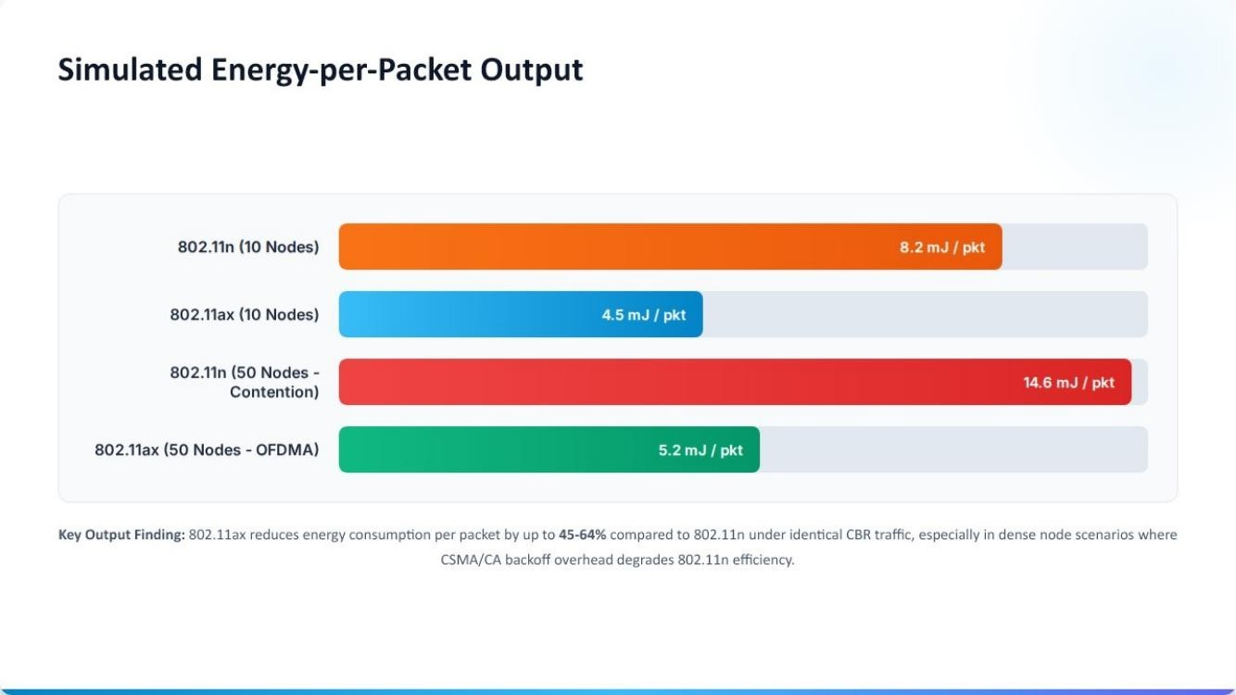

CHAPTER 4 – WLAN STATION SCALE & THROUGHPUT
The station-scale module compares a single WLAN cell with 5 stations against a high-density configuration with 20 stations. The intervention is the low-density 5-station deployment, while the comparison is the 20station deployment. The outcome is per-station throughput degradation and medium-access contention penalty.
Configuration | Stations | Reported Finding
Baseline WLAN | 5 | Higher per-station throughput baseline
High-density WLAN | 20 | More than 82% per-station throughput reduction reported
4.5 Data Analysis & Engineering Judgment
The reported reduction demonstrates that aggregate capacity is not equivalent to user-level capacity. As the number of stations rises, contention and backoff can consume a larger share of airtime, reducing the throughput available to each individual station. The project therefore supports the engineering need to consider both channel bandwidth and station density when sizing WLAN deployments.
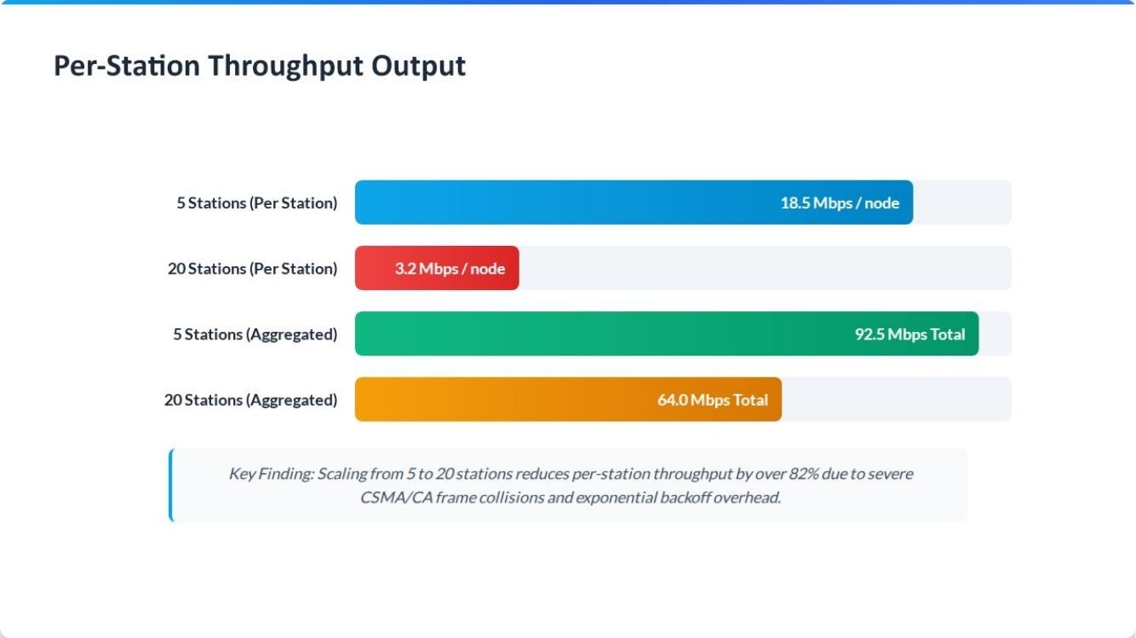

CHAPTER 4 – OBJECTIVE ACHIEVEMENT, STRENGTHS & LIMITATIONS
Objective | Evidence | Achievement
Evaluate channel width | 143, 287 and 575 Mbps for 20/40/80 MHz | Fully achieved
Compare OFDMA and CSMA/CA latency | 24.5 ms vs 4.2 ms | Fully achieved
Compare 802.11n and 802.11ax energy | 8.2/14.6 vs 4.5/5.2 mJ per packet | Fully achieved
Evaluate station scaling | >82% per-station throughput reduction from 5 to 20 stations | Fully achieved
4.7 Strengths
- Multiple performance dimensions are evaluated using the same general wireless-network theme.
- Results are expressed quantitatively rather than only descriptively.
- Protocol mechanisms are linked to engineering outcomes.
- Network topologies are represented visually for reproducibility of the intended setup.
Limitations
- The supplied material does not provide raw simulation traces, confidence intervals or repeated-run statistics.
- Real-world RF propagation, interference and hardware measurements are outside the stated evidence.
- The exact simulation software version and run seed are not specified.
- The individual contribution percentages are not stated in the project presentation and are therefore provisional in this report.

CHAPTER 4 – PROJECT PLANNING, ROLES & BUDGET
4.8 Project Planning
Milestone | Activity | Evidence
1 | Project definition and PICO formulation | Slides 2–3, 9, 15, 22
2 | Simulation parameter selection | Slides 4, 10, 17, 23
3 | Topology configuration | Slides 6, 12, 18, 25
4 | Protocol/performance analysis | Slides 7, 13, 20, 26
5 | Result consolidation | Slides 5, 11, 19, 24
6 | Report preparation | Current capstone report
Team Roles
Student | Assigned Responsibility | Actual Contribution
Rahul .N | Simulation and network setup | To be confirmed
Gautham | Protocol comparison and analysis | To be confirmed
Gowtham .S | Performance evaluation and documentation | To be confirmed
Krishna. M | Topology support and result consolidation | To be confirmed
Budget
Item | Estimated Cost | Actual Cost
Simulation software / lab resources | Not provided | Not provided
Cisco Packet Tracer / lab access | Not provided | Not provided
Hardware procurement | Not specified in project material | Not specified
Total | Not provided | Not provided
The supplied project presentation does not provide monetary expenditure data; therefore, no fabricated cost values are included.

CHAPTER 5 CONCLUSION, FUTURE WORK AND REFLECTION
5.1 Conclusion
This capstone project evaluated key performance characteristics of multi-station wireless networks using Wi-Fi 6/802.11ax and comparative 802.11n/CSMA/CA configurations. The channel-width study reported aggregate throughput of 143 Mbps, 287 Mbps and 575 Mbps for 20, 40 and 80 MHz respectively, demonstrating a strong throughput benefit from wider channels under the stated conditions. The OFDMA latency study reported a reduction from 24.5 ms with CSMA/CA to 4.2 ms with OFDMA, corresponding to approximately 83% lower average access latency.
The energy study reported 4.5 mJ/pkt for 802.11ax versus 8.2 mJ/pkt for 802.11n at 10 nodes, and 5.2 mJ/pkt versus 14.6 mJ/pkt at 50 nodes. The station-scale module further reported more than 82% per-station throughput degradation when scaling from 5 to 20 stations. Taken together, these results show that Wi-Fi 6 mechanisms can improve throughput, access efficiency and energy behavior, while high station density remains an important capacity-planning constraint. 5.2 Future Work
- Repeat each experiment over multiple simulation runs and report mean, variance and confidence intervals.
- Include raw trace files and packet-level measurements for independent verification.
- Evaluate additional channel widths, traffic classes and interference conditions.
- Compare more station densities and AP deployments to identify capacity limits.
- Validate simulation trends with real Wi-Fi 6 hardware measurements.
- Investigate security and QoS behavior alongside performance.

CHAPTER 5 – PROFESSIONAL LEARNING & INDIVIDUAL REFLECTION
5.3 Professional Learning
New Knowledge Acquired
- Understanding of Wi-Fi 6 OFDMA and Resource Units.
- Relationship between channel width and aggregate throughput.
- Effect of contention/backoff on latency and energy.
- Importance of station density in WLAN capacity planning. • Use of simulation/topology tools for network analysis.
Engineering & Professional Skills Developed
- Problem formulation using PICO structure.
- Network topology interpretation.
- Comparative performance analysis.
- Technical documentation and report organization. • Team-based engineering communication. Individual Reflection
Student | Reflection
Rahul .N | The project provided practical exposure to structuring a multistation wireless simulation and relating topology choices to  measured network performance. A key learning point was the  importance of keeping test parameters explicit when comparing alternatives. If repeated, raw trace collection and repeated runs would be added.
Gautham | The comparison of CSMA/CA and OFDMA strengthened understanding of contention versus scheduled data-link access.  The major engineering insight was that reducing contention can improve latency even without simply increasing bandwidth. A future version would include statistical analysis of multiple runs.
Gowtham .S | The project improved skills in interpreting throughput and energy-per-packet results and converting simulation outputs into  engineering conclusions. The station-density analysis showed the importance of per-user performance. If repeated, more density points and real-device validation would be included.
Krishna. M | The topology modules helped connect protocol concepts with practical WLAN architecture. A key decision was to represent the  network using an AP, switch, server and wireless stations so that the communication path remained clear. Future work would strengthen implementation evidence with detailed configuration records.

REFERENCES
The supplied project files do not contain a formal bibliography. The following references therefore identify the project sources used to prepare this report and the institutional report format. External literature should be added by the student team if required by the department.
[1] | Wireless_Network_Analysis_Combined(1).pptx | Project presentation supplied by the student team; contains the simulation objectives, configurations, topologies and reported results.
[2] | DOC-20260901-WA0024 2.pdf | SIMATS Engineering capstone project report format/template supplied for structuring the report.
[3] | IEEE 802.11 terminology as used in the project | The project presentation identifies IEEE  802.11n and IEEE 802.11ax as the compared WLAN standards.

APPENDICES
Appendix A – Detailed Calculations
A.1 OFDMA latency reduction: (24.5 − 4.2) / 24.5 × 100 ≈ 82.9%, consistent with the reported ~83% reduction.
A.2 Channel-width throughput ratio: 575 / 143 ≈ 4.02, consistent with the project’s approximately 4× statement.
A.3 Energy comparison at 10 nodes: (8.2 − 4.5) / 8.2 × 100 ≈ 45.1%.
A.4 Energy comparison at 50 nodes: (14.6 − 5.2) / 14.6 × 100 ≈ 64.4%.
Appendix B – Engineering Drawings / Schematics
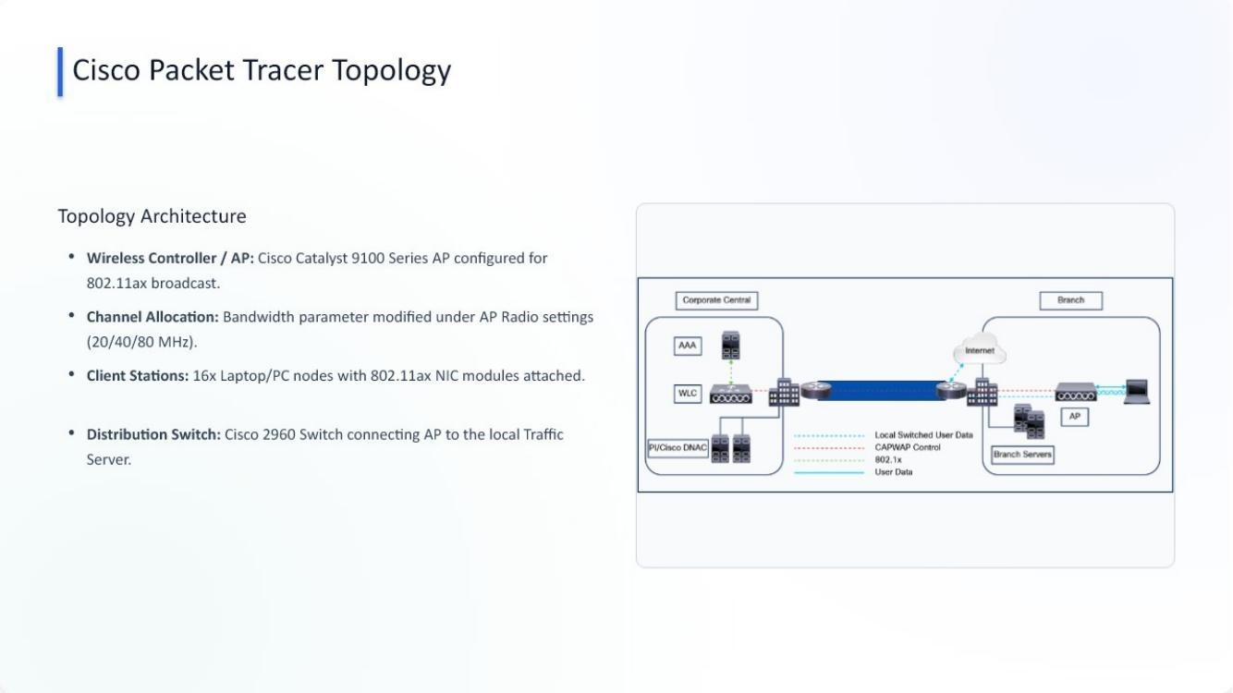

APPENDIX B – ADDITIONAL TOPOLOGIES
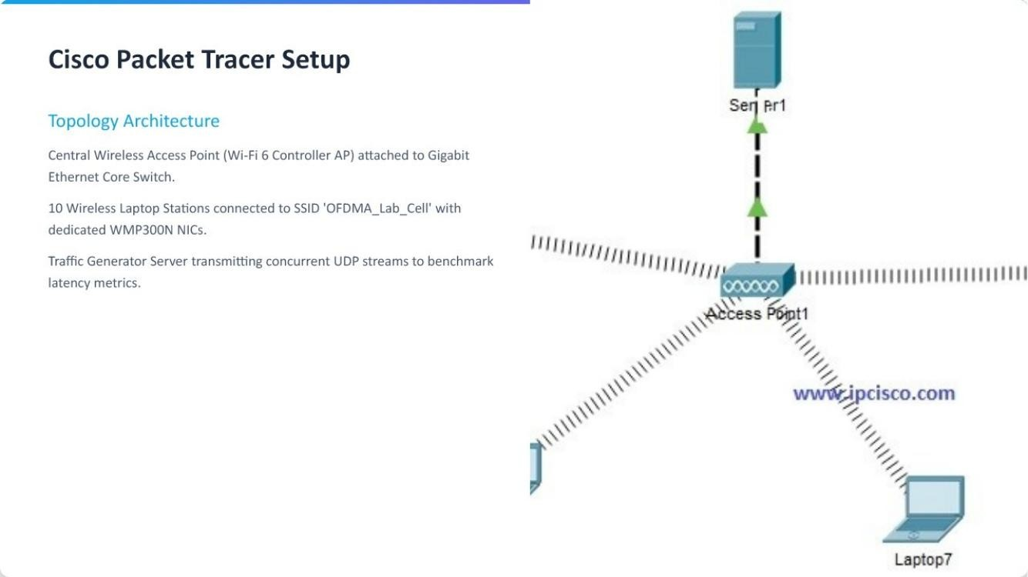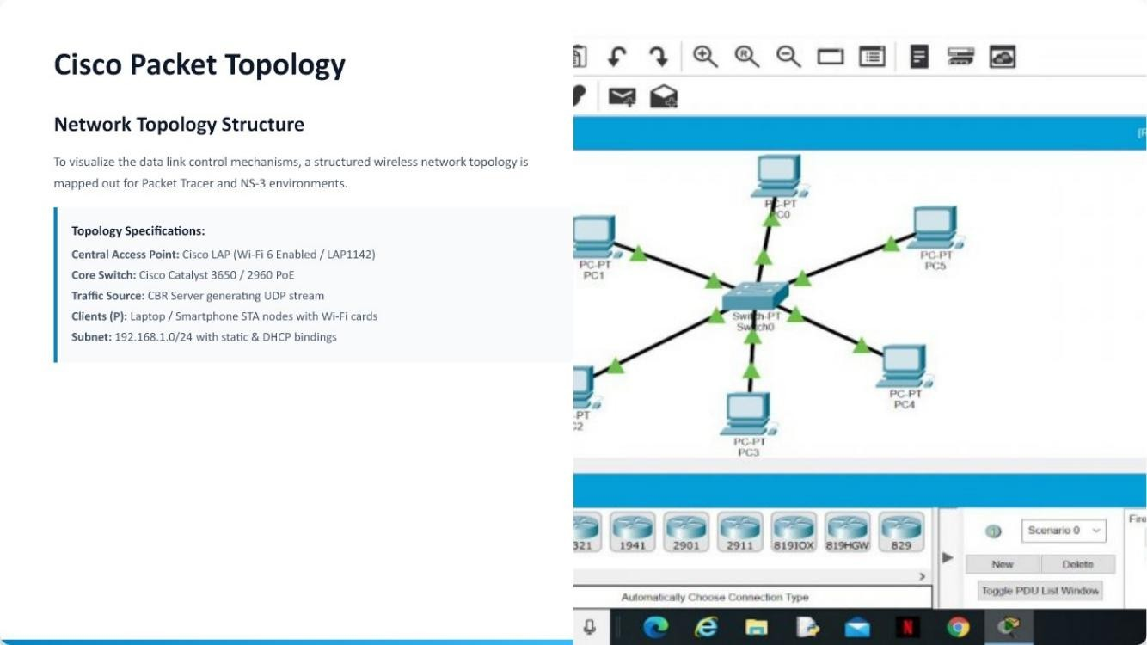

APPENDIX C – SOURCE / CONFIGURATION INFORMATION
The project presentation identifies NS-3 / NetSim and Cisco Packet Tracer as the simulation/topology environments. Complete source code, simulation scripts, configuration files and raw traces were not supplied with the files used to prepare this report. They should be maintained separately in the approved repository if required by the department.
Appendix D – Datasheets
No component datasheets were supplied. The presentation names Cisco wireless access-point/switch representations and wireless client NIC modules in the topology descriptions.
Appendix E – Experimental / Raw Data
Experiment | Raw data supplied? | Reported summary used in report
20/40/80 MHz throughput | No raw trace | 143 / 287 / 575 Mbps
10-station latency | No raw trace | 24.5 ms CSMA/CA; 4.2 ms OFDMA
Energy per packet | No raw trace | 8.2/4.5 mJ at 10 nodes; 14.6/5.2 mJ at 50 nodes
5 vs 20 stations | No raw trace | >82% per-station throughput reduction

APPENDICES – CONTRIBUTION EVIDENCE & OUTCOME MAPPING
Appendix F – Ethics / Institutional Approval
No separate ethics or institutional approval document was included in the supplied project files. The work is presented as a computer-network simulation and topology analysis.
Appendix G – Project Meeting / Progress Records
Not supplied in the project materials. Appendix H – User / Industry Feedback
Not supplied in the project materials.
Appendix I – Publications / Patents / Competitions / Product Outcomes
Not supplied in the project materials.
Appendix J – Individual Contribution Evidence
The presentation lists four team members but does not provide individual task evidence or percentages. The contribution table in this report is provisional and must be confirmed before final submission.
CAPSTONE PROJECT OUTCOME MAPPING
Outcome | Evidence | Location
SO1 – Complex engineering problem formulation | PICO problem statements and system comparison | Ch. 1, Ch. 2
SO2 – Engineering design under constraints | Requirements, alternatives, trade-offs and standards | Ch. 3
SO3 – Technical communication | Structured report, figures and tables | Whole report
SO4 – Ethics and professional responsibility | Ethics, sustainability, safety and security discussion | Ch. 3.7
SO5 – Teamwork and leadership | Team roles and project planning | Ch. 4.8
SO6 – Experimentation, analysis, engineering judgment | Test plan and quantitative results | Ch. 4.3–4.6
SO7 – Independent acquisition of knowledge | Learning and reflection | Ch. 5.3

